# **First**

# **Calendar Events**

• • •

**December 5th**

• 2 Hour Early Dismissal

•Unity Day – Wear Orange

**December 7th**

•Picture Day

Re-takes

**December 22nd**

•Holiday Luncheon

(Details to Follow)

**December 25th–December 29th**

• Schools closed – Winter Break

**Principal’s Message**

Dear Severn Families,

Welcome to December!

As the cold winter months approach and we begin thinking about the upcoming holidays, we typically pause to think of all the things which bring us great joy. Each day, I am humbled to work alongside such a dedicated and talented team of faculty and staff. In addition, I am exceedingly grateful for the amazing children that enter our doors daily ready and eager to learn. It is because of you that they are so extraordinary—Thank you for your hard work to raise such amazing children!

Please be sure to carefully review this newsletter for a detailed report of upcoming events as well as school news.

As a reminder, our school hours are 8:00-2:25 for all students, and doors open at 7:40.

I hope you all enjoy a relaxing and delightful winter vacation. See you all in 2024.

Kind Regards,

Mrs. Smith

Sincerely,

Isaphine Smith, Principal

Amy Worrall, Assistant Principal

**838 Reece Road**

**Severn, MD 21144**

**Principal: Isaphine Smith**

**Assistant Principal: Liz Abell**

**December 2023**

**@SevernESAACPS**

Severn Elementary School 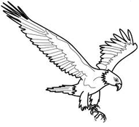

WINTER HOLIDAY LUNCHEON IS ON DECEMBER 22!!! PLEASE SEE FLYER BELOW TO SIGN UP. CHILD. 

**Winter Concert**

Please be sure to join us on January 11th at 6:00 p.m. for a combined chorus and instrumental concert. The chorus and instrumental students have been working very hard to create a wonderful show.

 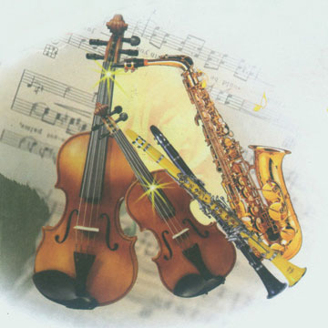



**

|  |  |  |  |  |
| --- | --- | --- | --- | --- |
|  |  |  |  | **1** Don’t be a Grinch!  Wear green |
| **4** Winter is coming!  Wear a cozy sweater and/or socks | **5** Early Release: Unity Day  Wear Orange | **6** Wear your favorite holiday sweater! | **7** Hanukkah starts  Wear blue and white | **8** Candy Cane Day!  Wear red and white |
| **11** Wear your favorite holiday socks! | **12** Get Cozy!  Wear plaid or flannel | **13** Workout Wednesday  Wear workout clothes | **14** Thoughtful Thursday  Spread some cheer - Show kindness to someone by giving them a compliment. | **15** It’s a Winter Wonderland!  Wear white |
| **18** Wear your favorite winter sports jersey! | **19** Christmas is in less than a week!  Wear green and red | **20** Spread the holiday cheer!  Wear holiday gear (headbands, hats, jewelry, etc.) | **21** Get your singing voices ready….  Listen for holiday tunes throughout the day! | **22** Movie Day!  Wear your cozy pajamas |

                           WINTER PARENT- STUDENT HOLIDAY LUNCHEON

Dear Parents/Guardians,

This year the annual Winter Parent-Student Holiday Luncheon will be held on Friday, December 22, 2023.  Parents/Guardians who wish to purchase a lunch from the school cafeteria may do so for $5.50.  Exact change, or small bills, are appreciated as the cafeteria has limited amounts of change available. We do not accept credit/debit cards. Outside food may also be brought in by parents/guardians for you and your child(ren) to eat, but please no peanuts or nut products.  The school menu for the luncheon is

Pizza

Hot vegetable of the Day

Baby Carrots (bagged)

Applesauce

Grab & Go

The lunch times have been adjusted to accommodate parents eating with their children.

**Grade Level Time**

Pre-K 10:30-11:00 AM

First 11:30-12:00 PM

Second 10:40-11:10 AM

Third 12:00-12:30 PM

Fourth 12:10-12:40 PM

Fifth 11:20-11:50 AM

**Please complete and return the bottom portion of this form to your child’s teacher by Wednesday,  December 13, 2023 if you plan to attend the luncheon so that we can pre-register your attendance and have a visitor badge ready for you. All information is required to preregister.**

**You may also complete this google form:** [**https://forms.gle/ewQTidBmk2WR8W42A**](https://forms.gle/ewQTidBmk2WR8W42A)

**If you will buy a school lunch, please put the number of lunches you are purchasing here: _______**

Child’s Name/Teacher**: ______________________________________________**

Parent/Guardian #1 Name: __________________________________ Birthdate: _________________

License # ____________________________

Parent/Guardian #2 Name: __________________________________ Birthdate: _________________

License # ____________________________



